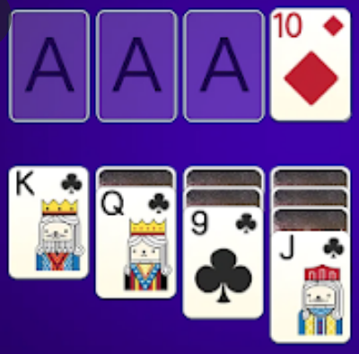

Project: Columns

The aim of the project is to develop a number game.

General Information

The game is played in 5 columns. Game elements are numbers (1-10). The aim of the game is reaching the highest score by collecting number sets.

Game Elements

Numbers
- Number set: 1, 2, 3, 4, 5, 6, 7, 8, 9, 10
- There are 5 number sets in the game. Total 50 numbers.

Box
- Source of numbers

Columns
- Game area. Numbers stay in columns.
- There are 5 columns.

Game Initialization

All numbers are shuffled in the box. Numbers in the box are invisible.
Numbers in the box are distributed to the columns until each column has 6 numbers.

Game Playing Information

There are 2 operations in the game:
- Column to column number transferring. Some numbers are transferred from one column to another.
- Drawing a number from the box (then transferring). Player can draw a number from the box if there is a number in it. Then player can transfer the drawn number to a column.

Column to Column Number Transferring:
Column to column transfer operation has two steps:
- Select a number from a column ("from" column) by moving the cursor to that number and pressing Z key. The numbers which will be transferred are the selected number and the ones below the selected number.
- Then select another column ("to" column) by moving the cursor to that column and pressing X key.
Transferred numbers are appended to this column (transfer condition must be fulfilled).

Drawing a number from the box (then transferring):
Drawing from the box and transferring has two steps:
- Draw a number by pressing B key (if there is an opened unused number in the box, no drawing occurs. In that case, B key just selects the box for from-part of the transfer)
- Then select a column ("to" column) by moving the cursor to that column and pressing X key.
The drawn number is transferred to the end of this column (transfer condition must be fulfilled).

Transfer condition:
- a: Selected number in from-column (or drawn number from box).
b: The last number in to-column.
Difference between a and b must be 0 or 1 or -1.
- If to-column is empty, the top number of the transferred numbers must be 1 or 10.

Aim of the transfer is to form an ordered set (1-2-3-4-5-6-7-8-9-10) or reverse ordered set (10-9-8-7-6-5-4-3-2-1) in a column. These numbers must be ordered and there must be no other numbers in the column. Player gets 1000 points column score for each ordered set. The completed set disappears.

Sample Game Screens

C1 C2 C3 C4 C5 Transfer: 17  -- -- -- -- -- Score : 1000  5 3 2 4  7 1 1 10  10 6 8 9 Box  9 4 8 +--+  7 3 7 | |  2 +--+  1  C1 C2 C3 C4 C5 Transfer: 18  -- -- -- -- -- Score : 1000  5 3 2 4  1 1 10  6 8 9 Box  9 4 8 +--+  7 3 7 | |  7 2 +--+  10 1  C1 C2 C3 C4 C5 Transfer: 19  -- -- -- -- -- Score : 1000  5 3 2 4  4 1 1 10  3 6 8 9 Box  2 9 8 +--+  1 7 7 | |  7 +--+  10  C1 C2 C3 C4 C5 Transfer: 20  -- -- -- -- -- Score : 1000  5 3 2 10 4  4 1 1 9  3 6 8 8 Box  2 9 7 +--+  1 7 | 6|  7 +--+  10 | C1 C2 C3 C4 C5 Transfer: 21  -- -- -- -- -- Score : 1000  5 3 2 10 4  4 1 1 9  3 6 8 8 Box  2 9 7 +--+  1 7 6 | |  7 +--+  10  C1 C2 C3 C4 C5 Transfer: 22  -- -- -- -- -- Score : 1000  3 2 10 4  1 1 9  6 8 8 Box  9 7 +--+  7 6 | |  7 5 +--+  10 4  3  2  1  C1 C2 C3 C4 C5 Transfer: 23  -- -- -- -- -- Score : 2000  10 3 2 4  1 1  6 8 Box  9 +--+  7 | 5|  7 +--+

End of the Game and Scoring

Player can finish the game by collecting 5 ordered sets or can exit the game by pressing E key.
End game scoring is calculated by the following formula.

End-Game Score = 100*Finished_ordered_sets + ( Score /Transfer_number )

After game finishes, High Score Table for end-game scores are displayed in descending order.
Default High Score Table for the game (in the following order in "highscore.txt" file):
- Sema Fırat 378.24
- Tarık Deniz 521.07
- Ali Vadi 136.32
- Seda Rüzgar 224.67

Structures

Box : Singly Linked List (SLL)
High Score Table : Doubly Linked List (DLL)
Columns : Multi Linked List (MLL)

